How To Trace Your Facebook Profile Visitors:

Now here we found who recently visited your profile.
Follow below steps for get to know your FB recent visitors.
Step (1) Go to your Facebook Profile Page.
Step (2) Now Press Ctrl + U from your keyboard for see source code of your profile page.
Step (3) Now press Ctrl + F from your keyboard to open search box.
Step (4) Now search this code {"list":
Step (5) You find some Facebook Profile Ids are like shown below. Click on example image for zoom.
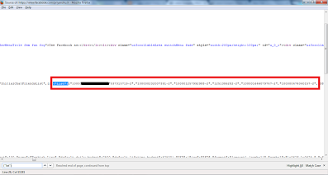
Step (6) There are some Facebook Profile Ids of your friends who visited recently.
Step (7) The first one ID's are showing visits the most number of time.
Step (8) Now if your want to findout, Open a new tab Enter below link :s
www.facebook.com/Facebook Profile Id
For Example : www.facebook.com/100001257992988

Enjoy the trick friends:
By your,
Akash Prasanna
Contact me:
Fb: https://www.facebook.com/akash.maddy1
e-mail ur q&a to: prince391997@gmail.com
website: www.princeguy.weebly.com
if u hav any hacking or cyber security tools, or if u know any tricks to hack please contact me in e-mail or fb …..

