How To Identify Fake Facebook Accounts:

Facebook or Fakebook ?
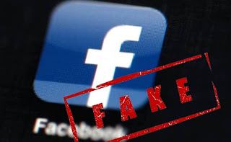

How can you detect the Fake FB Profile. On these days we are getting so many friend request specially by girls, but there is no way to identify that account is fake or original. So don't worry we are going to tell you simple method to detect fake Facebook account.
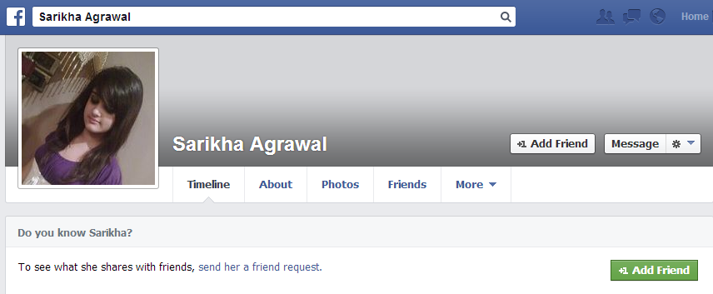
So this is a Facebook account which named by Sarikha Agarwal. Now we need to verify this account real or fake, so our first step is going to the images.google.com and click on camera image.
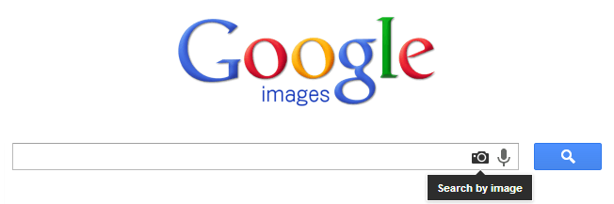

So when you click on search by image you will get popup like below image.

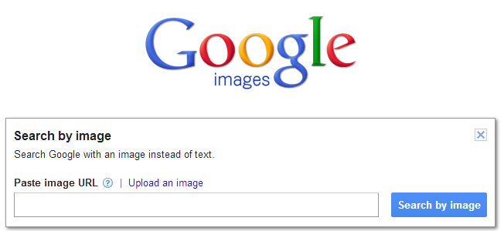

Now go to that profile, right click on image and click on copy image URL

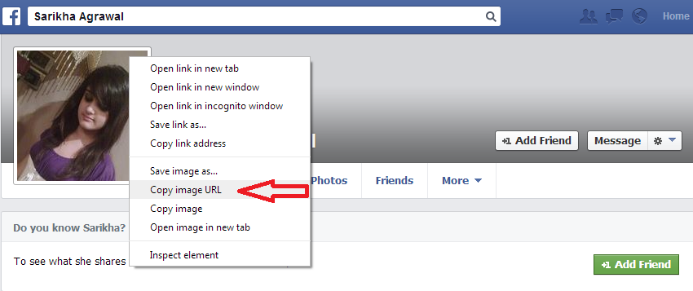

Now profile pic URL has copied.. now again go to images.google.com Tab and paste image URL

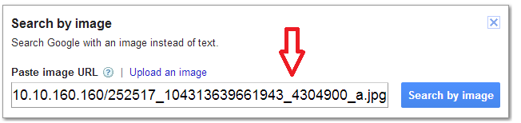

When you enter then you get related images search...

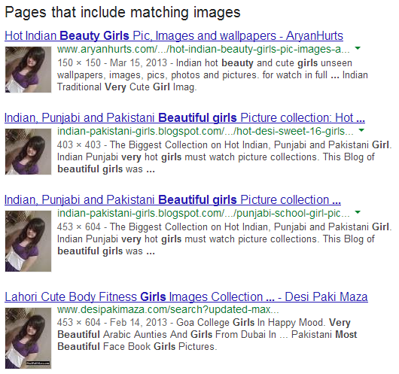
Now you can better see that this profile is real or fake..So here is a proof that this profile is fake. Enjoy the trick..
Be aware when you will going to add an beautiful or smart unknown person as your friend. So be checked first.. there are lot of fake profiles are create everyday.
This person might be spy on your profile and steal personal information like your photos, etc for their hacking stuffs.. So Be Safe Online..

